**Importing QTI Test Bank into Canvas**

1. After logging into your [verified OpenStax Educator account](https://openstax.secure.force.com/help/articles/FAQ/Requesting-Instructor-only-access-to-the-resources-on-openstax-org), access the QTI test bank in Google Drive from the book’s Instructor Resources page. Download individual chapter QTIs to your device.

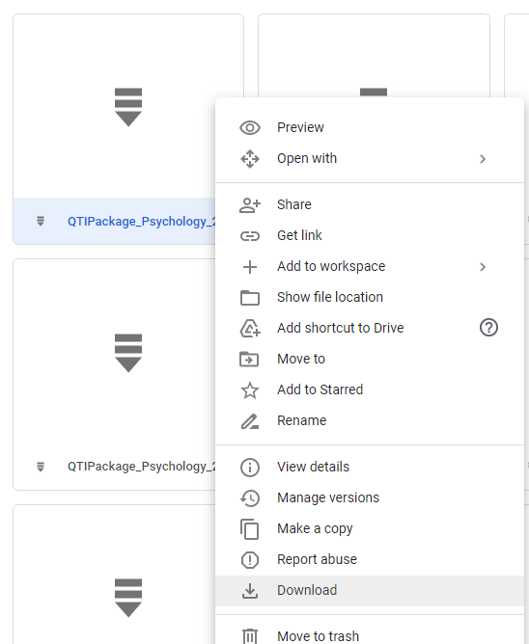

2. Log into your Canvas account.

3. Under **Settings,** select **Import Course Content** on the right

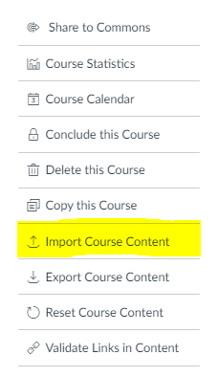

4. Under **Content Type,** select **QTI .zip file**

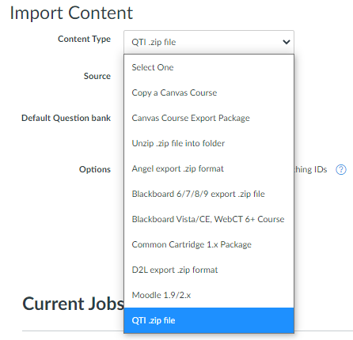

5. Under **Source**, click the **Choose file** button

6. Access the QTI file for the chapter you wish to import and select **Open**

**Note**: Chapter question banks will need to be uploaded one by one, repeating this process for each chapter QTI file

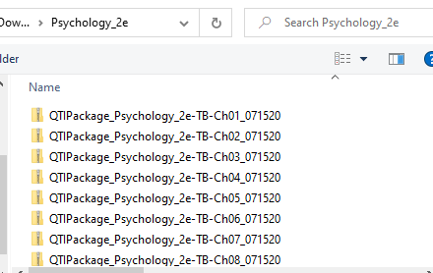

7. Under **Default Question Bank**, select **Create new question bank**

8. Fill in the Question bank name field to proceed;

**Note**: this title will not transfer once the file uploads to the Course Question Banks. You should be able to tell which file was uploaded by the time stamp.

9. Click **Import**

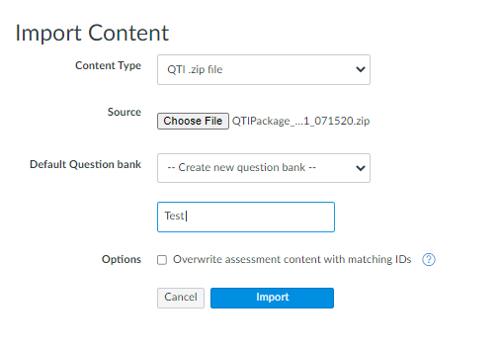

10. Once loaded, the status should change from running to **Completed**

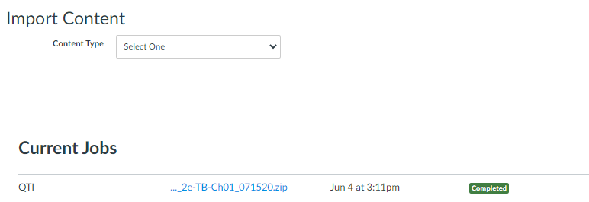

11. Select **Quizzes** on the left.

12. Next to the **+Quiz** button, click on the dots to the right and select **Manage Question Banks**

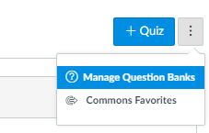

13. Each chapter file will upload with the title **No Name - Test Course**. Look for the time stamp to locate the file you just uploaded.

14. Once you open the question bank, all of the chapter questions will appear. Question labels should match the chapter title.

15. Repeat steps 3-15 to upload the rest of the chapters into Canvas.